Project 5
  - Nadia Shabeer
Objective: Deploy a highly available, auto‑scaling 3‑tier architecture with full CI/CD.

Architecture
Insert

Part 1: Setting up the Multi-AZ VPC Foundation
VPC
- Select "VPC and more" (This is a shortcut that builds everything at once).
- Name tag: Type Project5-VPC.
- IPv4 CIDR block: Keep it at 10.0.0.0/16.
  - Explanation: This is the range of IP addresses your network can use. It provides about 65,000 addresses.
- Number of Availability Zones (AZs): Choose 2.
  - Why: This ensures High Availability across two different data centers.
- Number of Public Subnets: Choose 2.
- Number of Private Subnets: Choose 4.
  - Why 4? We need 2 for our Application layer and 2 for our Database layer.
- NAT Gateways: Select 1 per AZ. Or 1 in 1 AZ
- VPC Endpoints: Select S3 Gateway. (This allows your servers to talk to AWS storage faster).
- Click Create VPC.
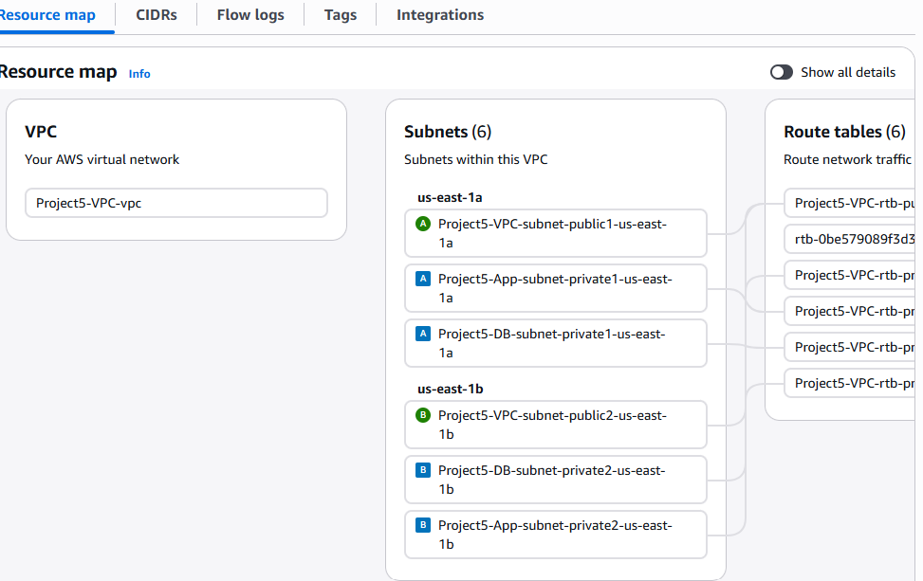

Part 2: The Database Layer (RDS HA & Read Replicas)

Step 1: Create a DB Subnet Group
- In the AWS Console search bar, type RDS and click it.
- On the left sidebar, click Subnet groups.
- Click the orange Create DB subnet group button.
- Name: project5-db-subnet-group
- Description: Subnet group for Project 5 Databases
- VPC: Select Project5-VPC (the one we made in Part 1).
- Availability Zones: Select the two AZs you used in Part 1 (usually us-east-1a and us-east-1b).
- Subnets: Select the two Private DB Subnets you labeled in Part 1.
- Click Create.
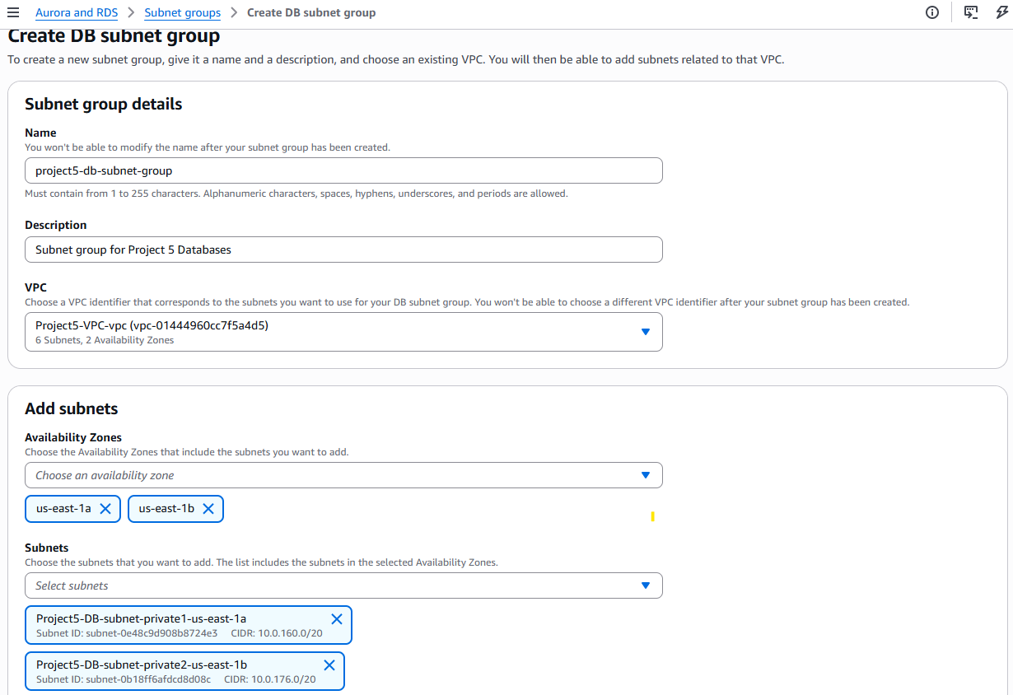

Step 2: Create a Security Group (The Firewall)
- Go to the VPC Dashboard > Security Groups.
- Click Create security group.
- Name: Project5-DB-SG
- Description: Allow traffic from App Tier
- VPC: Select Project5-VPC.
- Inbound Rules: Click Add rule.
  - Type: MySQL/Aurora (or PostgreSQL if you prefer).
  - Port: 3306 (for MySQL).
  - Source: For now, set this to your VPC CIDR (10.0.0.0/16). Note: In a production environment, you would later restrict this specifically to the Security Group of your Application servers.
- Click Create security group.
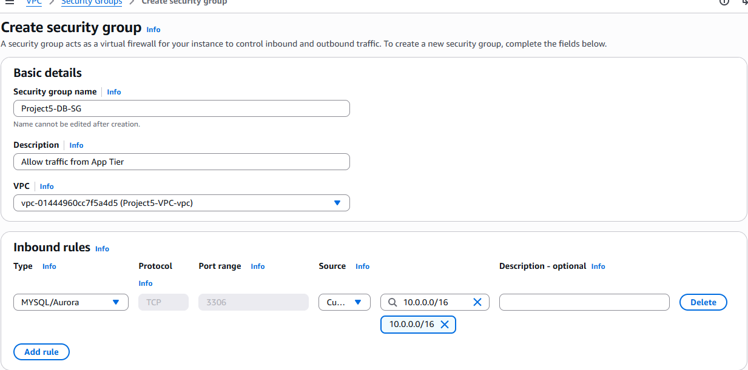

Step 3: Launch the Multi-AZ Database
- Go back to the RDS Dashboard and click Databases on the left.
- Click Create database.
- Choose a creation method: Standard create.
- Engine options: MySQL (latest version).
- Templates: Dev/Test (This allows Multi-AZ; "Free Tier" does not).
- Settings:
  - DB instance identifier: project5-primary-db
  - Master username: admin
  - Master password: Project5Password! (Save this!)
- Instance configuration: Choose t3.micro or t3.small (to keep costs low).
- Availability & durability: Select Create a standby instance (recommended for multi-AZ deployment).
  - This is the "High Availability" part!
- Connectivity:
  - Virtual private cloud (VPC): Project5-VPC
  - DB Subnet group: project5-db-subnet-group
  - Public access: No (Very important for security).
  - Existing VPC security groups: Remove default and select Project5-DB-SG.
- Click Create database. (This will take about 5–10 minutes).
- 1 day backup retention and 20GB storage
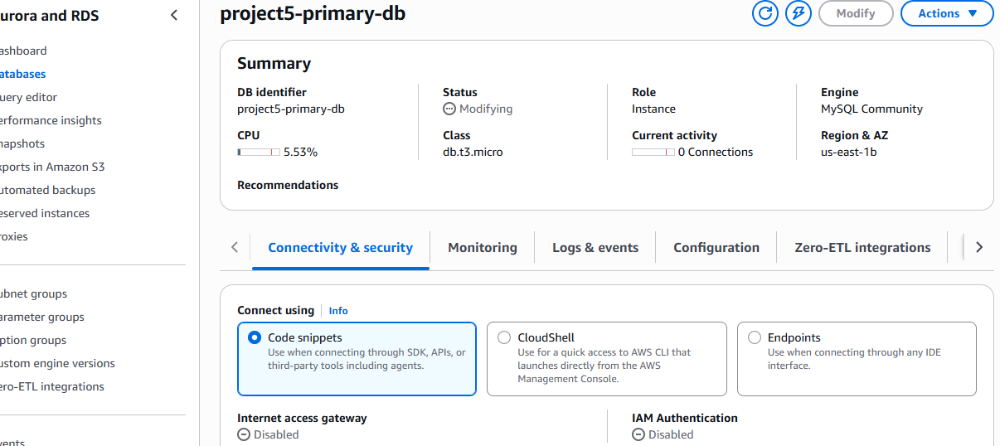

Step 4: Create a Read Replica (The Scaling Part)
- Wait until your project5-primary-db status shows as Available.
- Select the radio button next to project5-primary-db.
- Click the Actions button at the top and select Create read replica.
- DB instance identifier: project5-read-replica
- Instance configuration: Same as primary (t3.micro).
- Multi-AZ: No (Replicas usually don't need their own standby).
- Scroll to the bottom and click Create read replica.

Part 4: The Application Tier (AWS Elastic Beanstalk)

Step 1: Configure Environment
- Environment tier: Select Web server environment.
- Application name: Project5-App.
- Environment name: Project5-App-env (This auto-populates).
- Domain: Leave blank (it will give you a random AWS URL).
- Platform:
  - Platform: Select Node.js (or Python/Java depending on your preference, but Node.js is standard for this project).
  - Platform branch: Keep the recommended (e.g., Node.js 20 running on 64bit Amazon Linux 2023).
  - Platform version: Keep recommended (Latest).
- Application code: Select Sample application. (We will upload our real code later via CI/CD).
- Presets: Select High availability (This is critical! It ensures the Load Balancer and Auto Scaling are configured for Multi-AZ).
- Click Next.
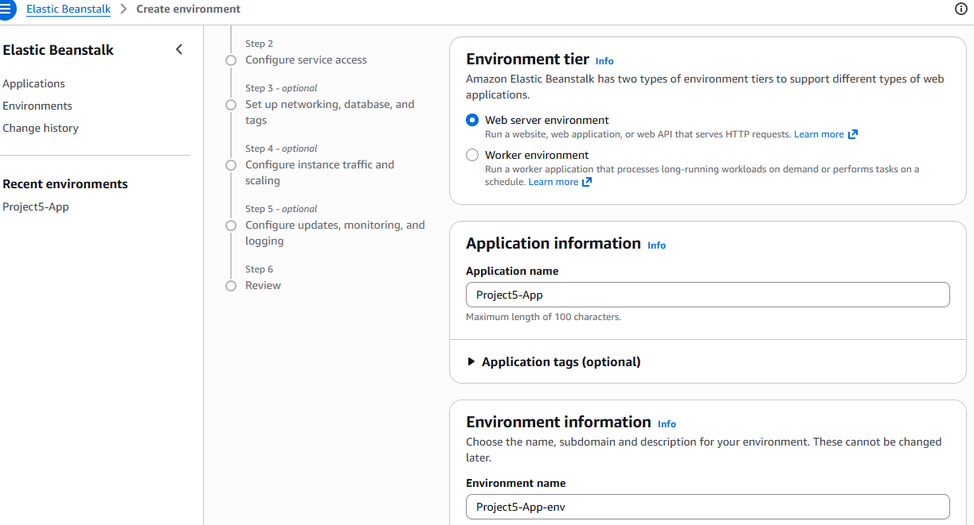
- Service Role: Select Create and use new service role.
- Service role name: aws-elasticbeanstalk-service-role.
- EC2 key pair: If you have one, select it. If not, click "Create a new key pair" in a new tab, then refresh this list. (Needed if you ever want to log into the servers).
- EC2 instance profile:
  - You likely don't have one yet. Click the link "Create a new IAM Role" (it opens in a new tab).
  - Select AWS Service -> EC2.
  - Search and attach these 3 policies:
    - AWSElasticBeanstalkWebTier
    - AWSElasticBeanstalkWorkerTier
    - AWSElasticBeanstalkMulticontainerDocker
  - Name the role Beanstalk-EC2-Role and click Create.
  - Go back to the Beanstalk tab and select Beanstalk-EC2-Role from the dropdown (you might need to hit the refresh icon).
- Click Next.
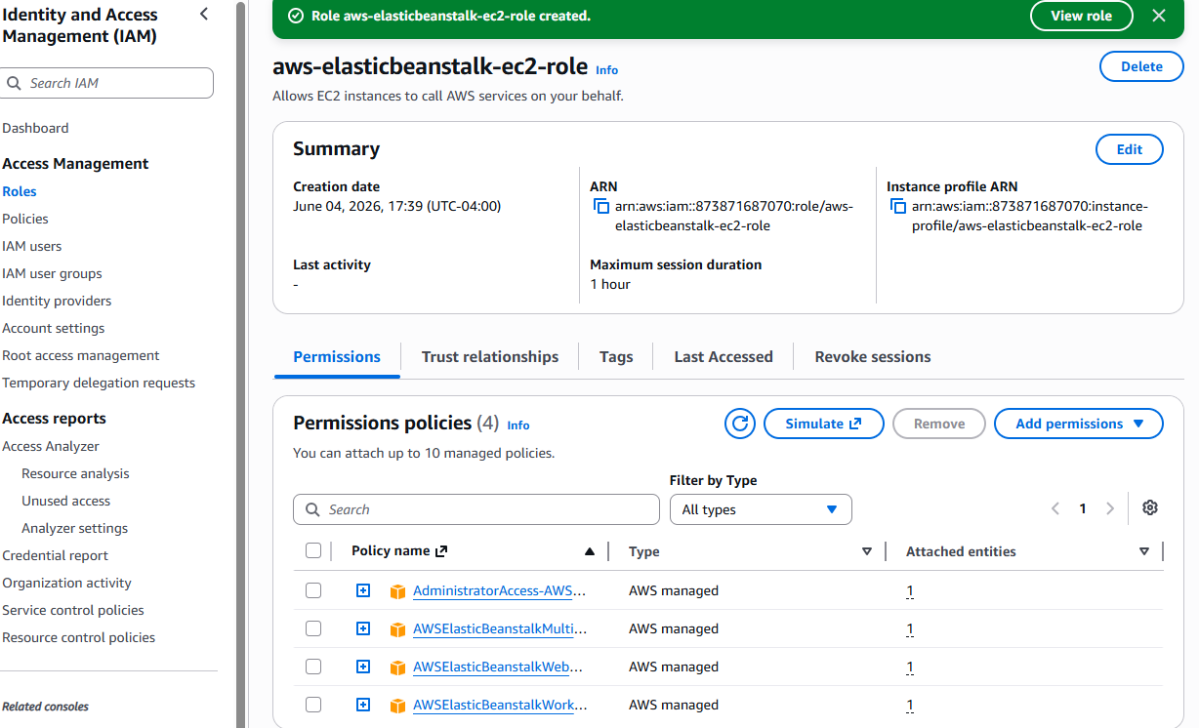
- VPC: Select Project5-VPC.
- Instance settings:
  - Public IP address: Uncheck this (Our servers will be in private subnets).
  - Instance subnets: Select your two App-Private-Subnets (from Part 1).
- Database: DO NOT click "Enable database" here. We already created our database in Part 2.
- Click Next.
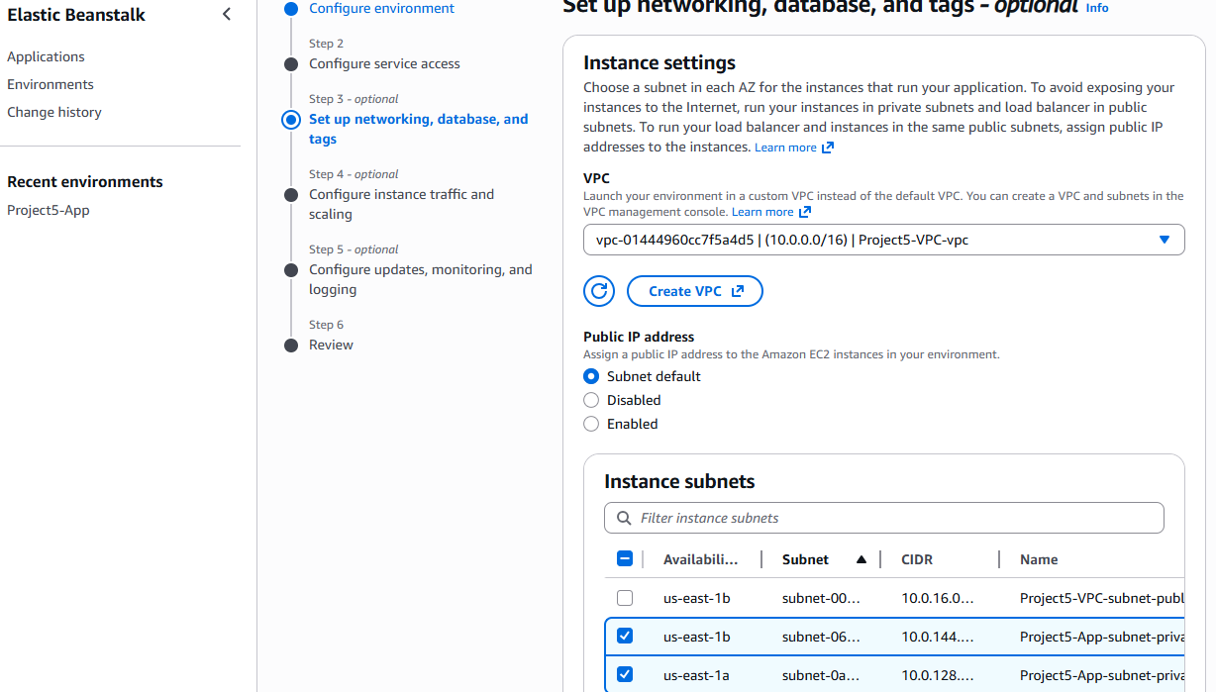
- Root volume: Container (Default).
- EC2 security groups: Select the default for now (we will refine this later).
- Auto Scaling Group:
  - Scaling policy: Select Load balanced.
  - Instances: Min: 2, Max: 4. (This ensures High Availability).
  - Availability Zones: Choose Any 2.
- Scaling Triggers:
  - Metric: CPUUtilization.
  - Statistic: Average.
  - Unit: Percent.
  - Upper threshold: 70 (Scale up when CPU is 70%).
  - Lower threshold: 30 (Scale down when CPU is 30%).
- Load Balancer network settings:
  - Visibility: Public.
  - Load balancer subnets: Select your two Public Subnets. (The LB must be public to talk to the internet).
- Click Next.
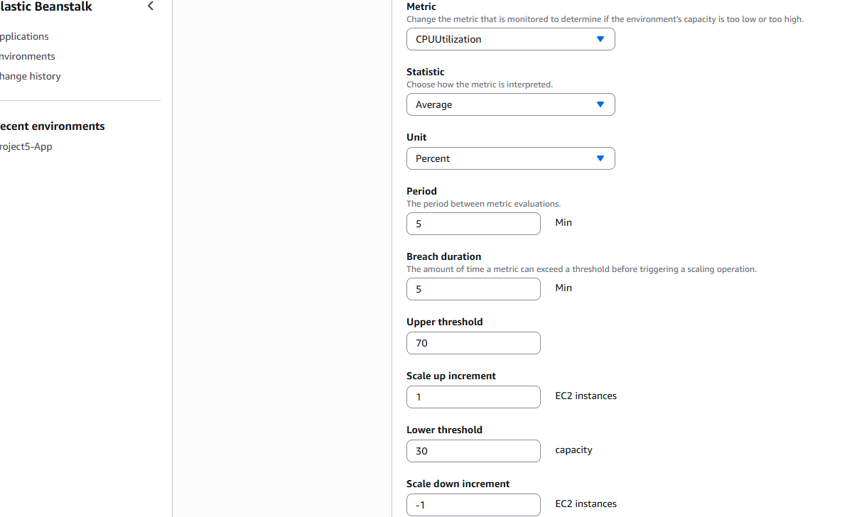
- Monitoring: Leave Health reporting as Enhanced.
- Managed updates: Uncheck "Activated" (to avoid unexpected changes during the project).
- Notifications: Leave blank.
- Platform updates: Leave as default.
- Deployment policy: Select Rolling.
- Environment properties: This is where we tell our code how to find the DB. Add these:
  - DB_HOSTNAME: (Copy the "Endpoint" from your RDS Primary DB in the RDS console).
  - DB_USER: admin
  - DB_PASSWORD: Project5Password!
- Click Next.
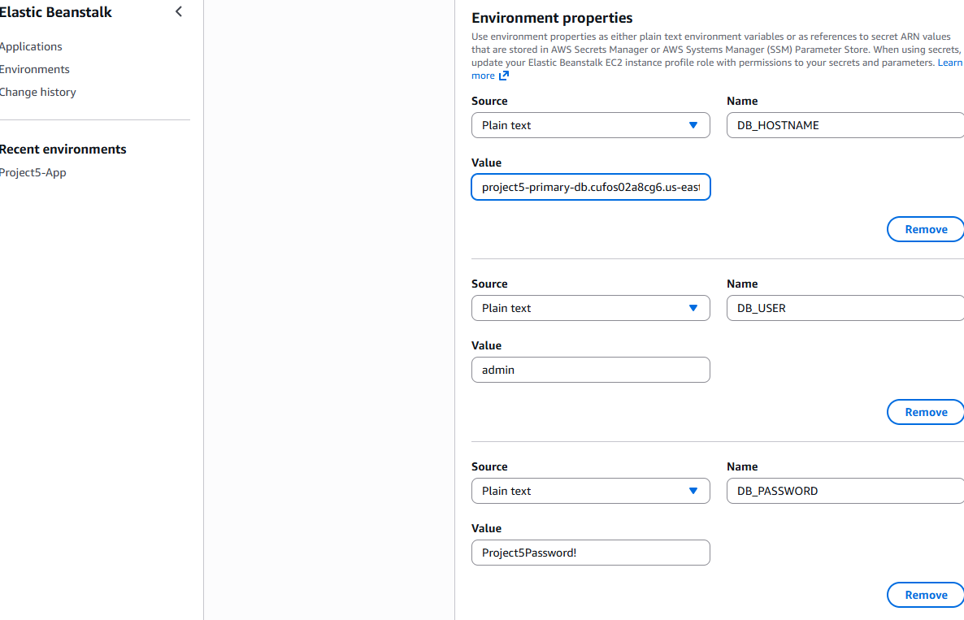
- If you don't specifically need encryption for this project, click Manage and uncheck "Always encrypt new EBS volumes." In EC2 attributes
- Check the events log under beanstalk and check the activity log under ASG for more details of what goes wrong.
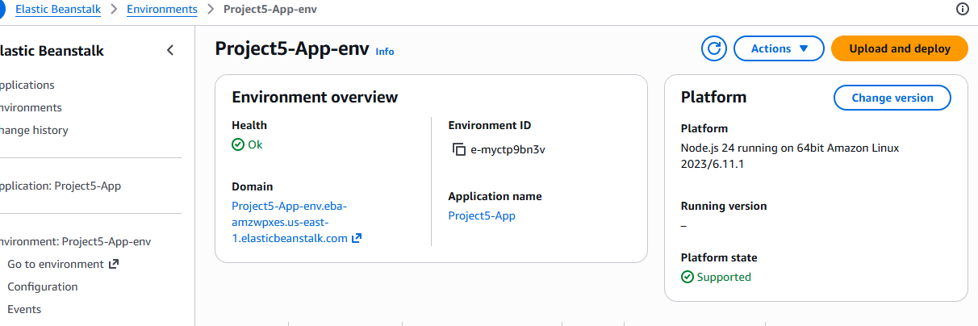

Part 5: CI/CD Pipeline (GitHub Actions to Elastic Beanstalk)

Step 1: Create an IAM User for GitHub
- Search for IAM in the AWS console.
- Click Users > Create user.
- User name: GitHub-Pipeline-User. Click Next.
- Permissions: Select Attach policies directly.
- Search for and select:
  - AdministratorAccess-AWSElasticBeanstalk
- Click Next > Create user.
- Click on the newly created GitHub-Pipeline-User.
- Click the Security credentials tab.
- Scroll down to Access keys and click Create access key.
- Select Command Line Interface (CLI), check the "I understand..." box, and click Next.
- Click Create access key.
- CRITICAL: Copy the Access Key ID and Secret Access Key. You will not see the Secret again!
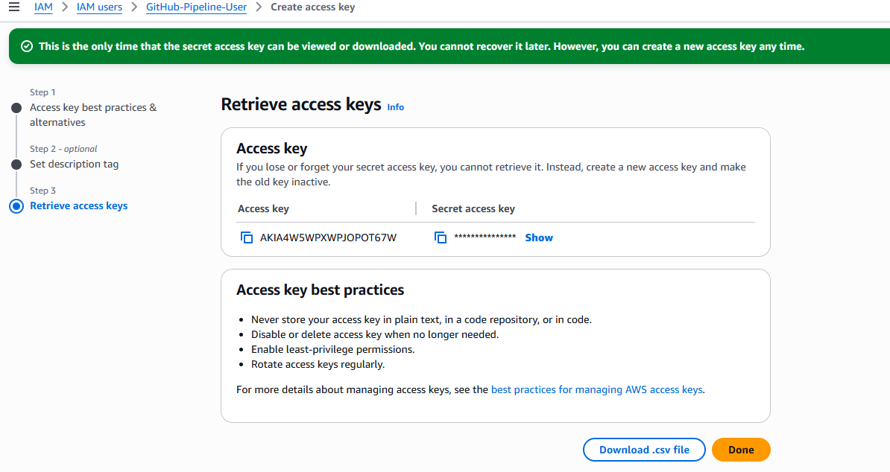

Step 2: Set up GitHub Secrets
- Go to your GitHub Repository for this project.
- Click Settings (top tab).
- On the left sidebar, click Secrets and variables > Actions.
- Click New repository secret.
- Add the following three secrets:
  - Name: AWS_ACCESS_KEY_ID | Value: (Paste your ID)
  - Name: AWS_SECRET_ACCESS_KEY | Value: (Paste your Secret)
  - Name: AWS_REGION | Value: us-east-1
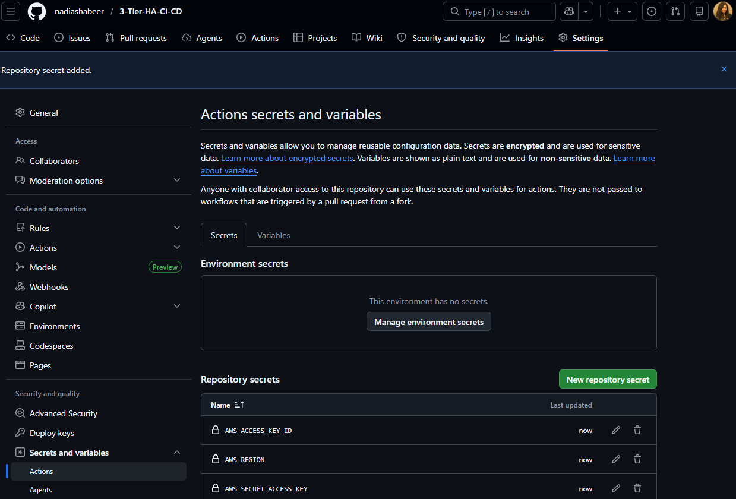

Step 3: Create the CI/CD Script (The YAML)
- In your local project folder (on your computer), create a folder named .github (note the dot).
- Inside .github, create a folder named workflows.
- Inside workflows, create a file named deploy.yml.
- Paste the following code into deploy.yml:
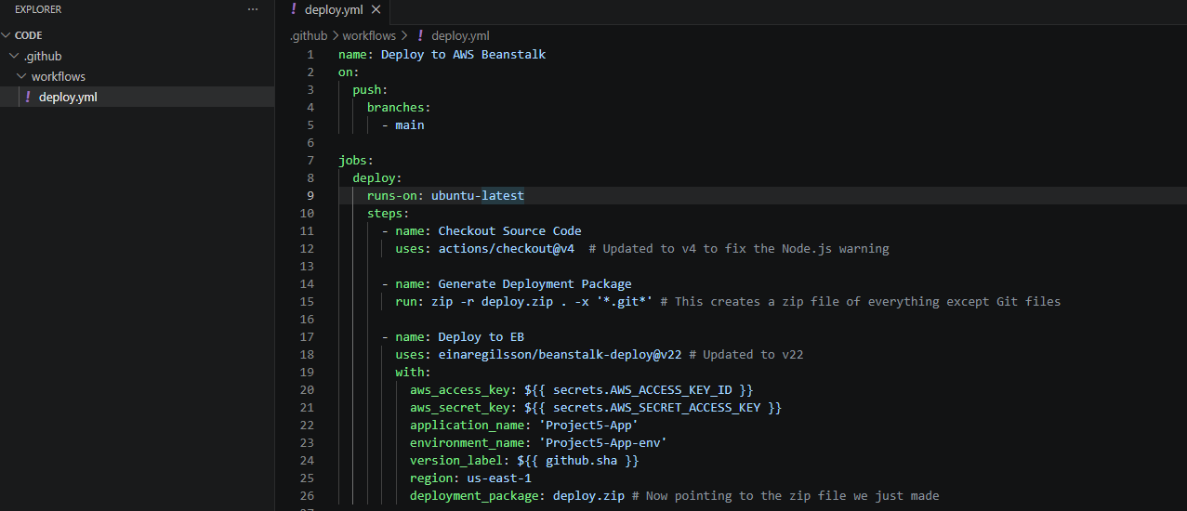

In the terminal:
- git init
- git remote add origin https://github.com/nadiashabeer/3-Tier-HA-CI-CD.git
- git add .
- git commit -m "Initial setup with CI/CD pipeline"
- git branch -M main
- git push -u origin main
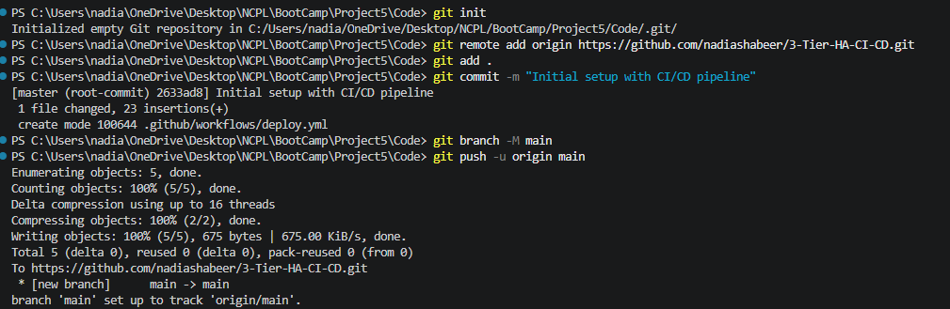

The Code

Step 1: Create the package.json (The ID Card)
- In VS Code, click the New File icon in your project folder (the same level as your .github folder).
- Name it package.json.
- Paste this code:
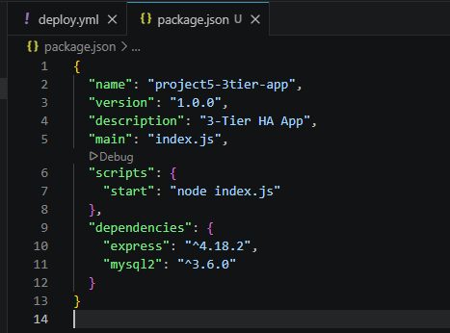

Step 2: Create the index.js (The Brain)
- Create another new file in the same folder.
- Name it index.js.
- Paste this code:

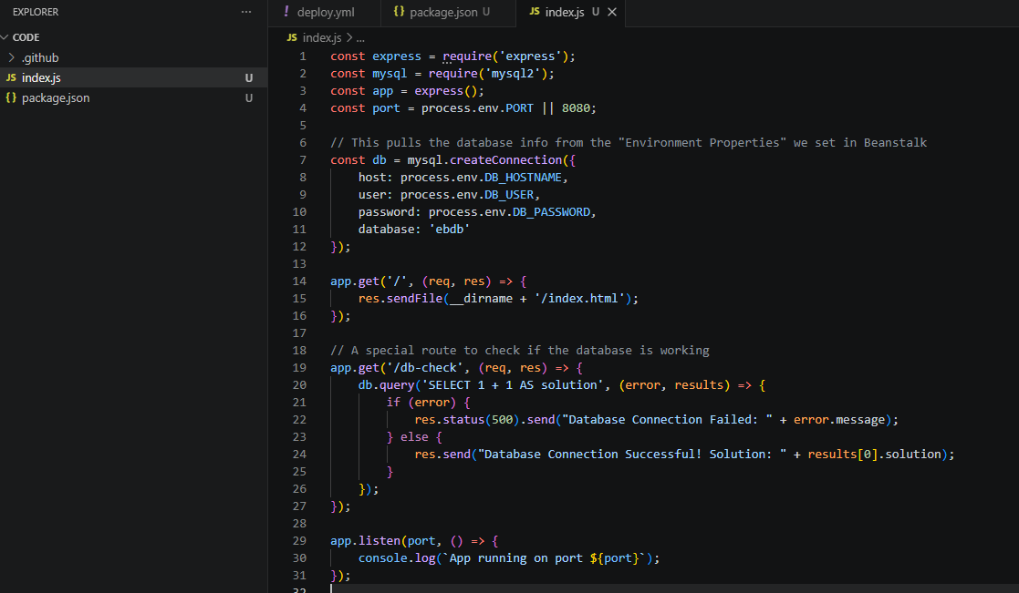

Step 3: Create the index.html (The Face)
- Create one last file.
- Name it index.html.
- Paste this code:
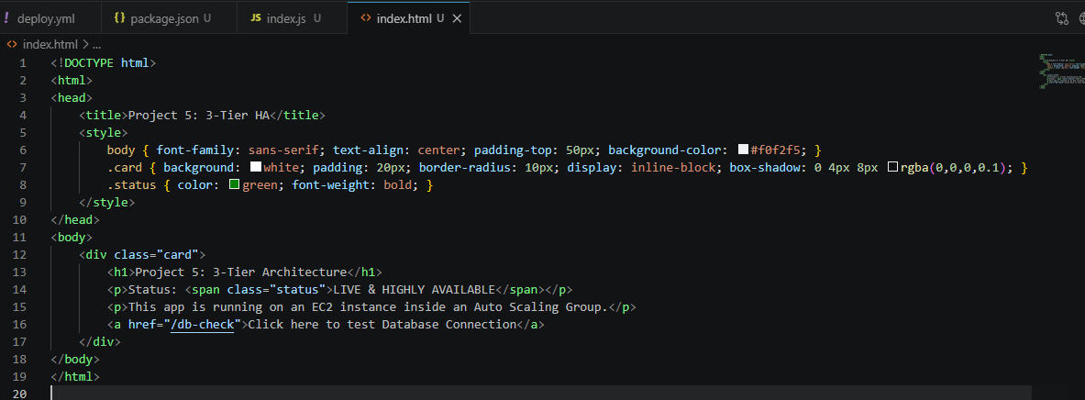
- git add .
- git commit -m "Added application code and fixed directory structure"
- git push origin main
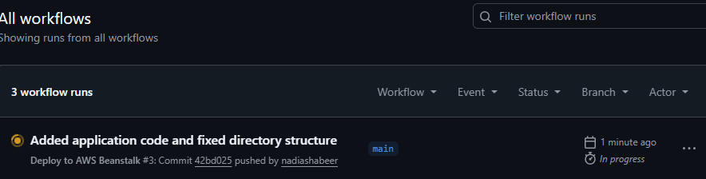
Add s3access to ec2 role
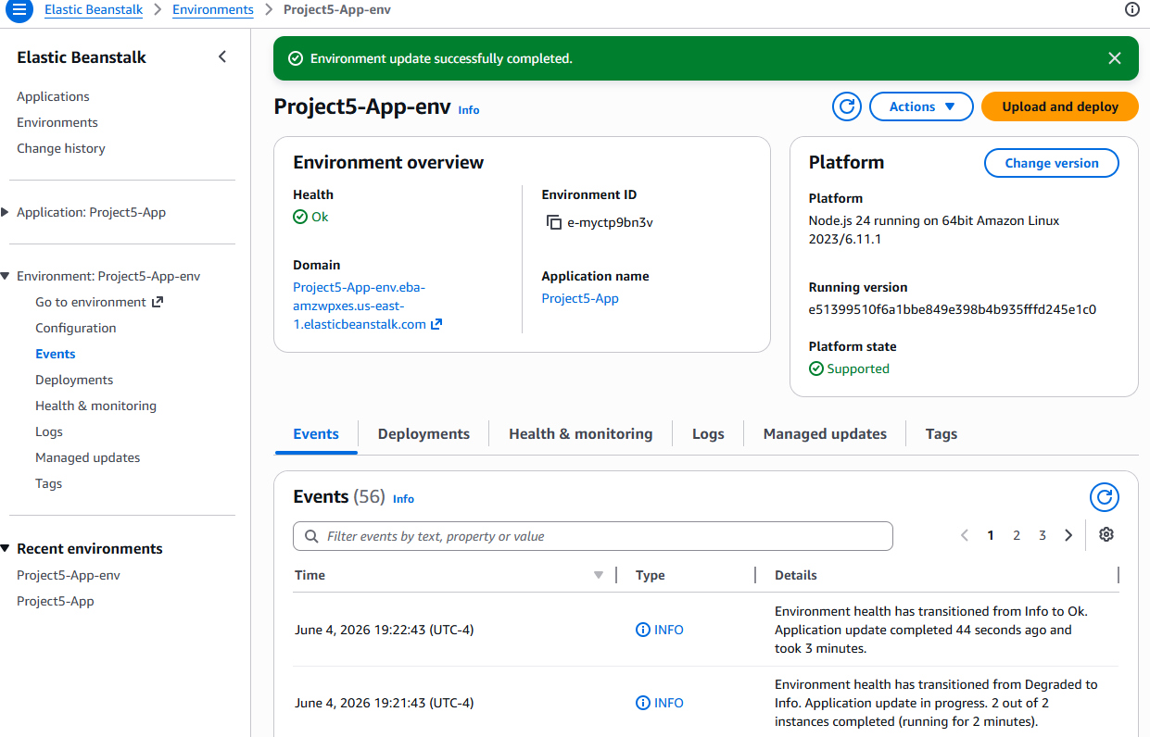

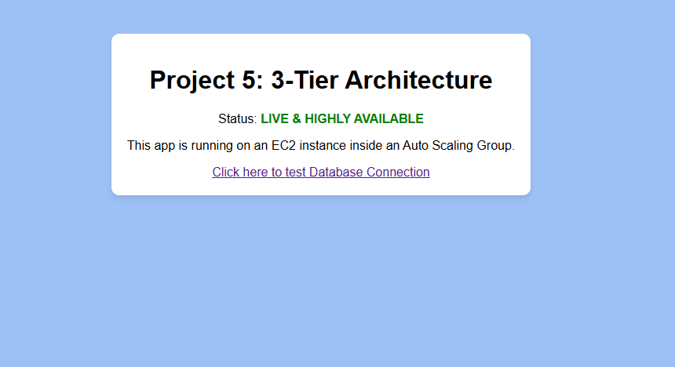

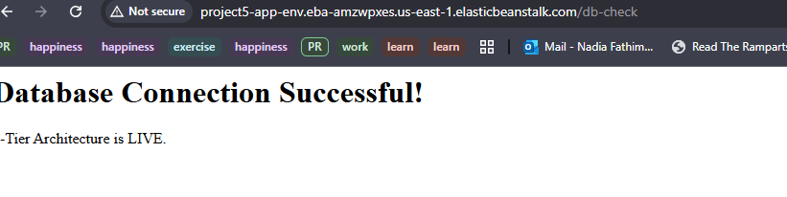
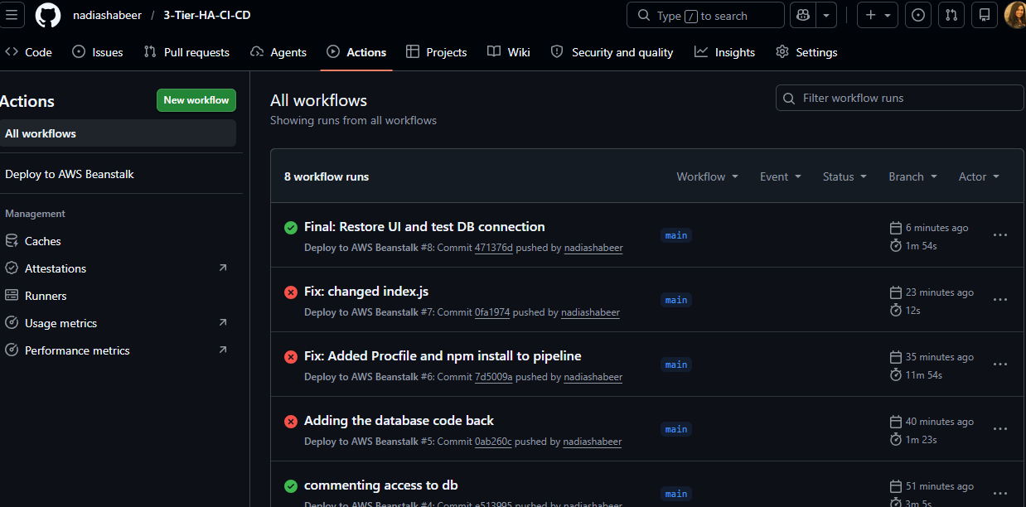
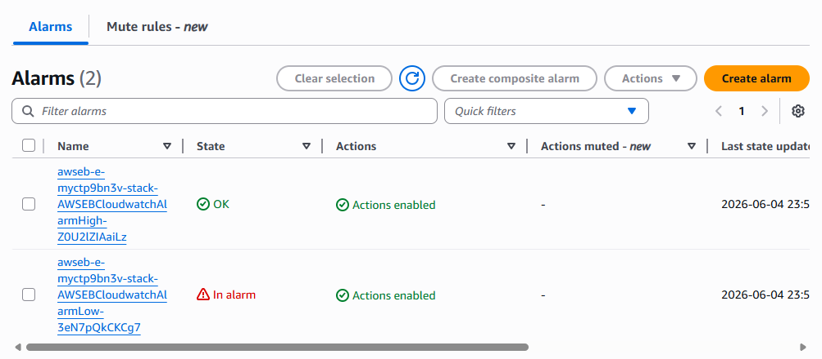

Step 1: Launch the Jenkins Server
- Go to EC2 -> Instances -> Launch Instance.
- Name: Project5-Jenkins-Server.
- OS: Amazon Linux 2023.
- Instance Type: t3.small (Jenkins needs at least 2GB of RAM; t2.micro will likely crash).
- Network:
  - VPC: Project5-VPC.
  - Subnet: Public Subnet 1.
  - Auto-assign Public IP: Enable.
- Security Group: Create a new one named Jenkins-SG.
  - Allow SSH (Port 22) from your IP.
  - Allow Custom TCP (Port 8080) from your IP (This is the Jenkins default port).
- Launch it.
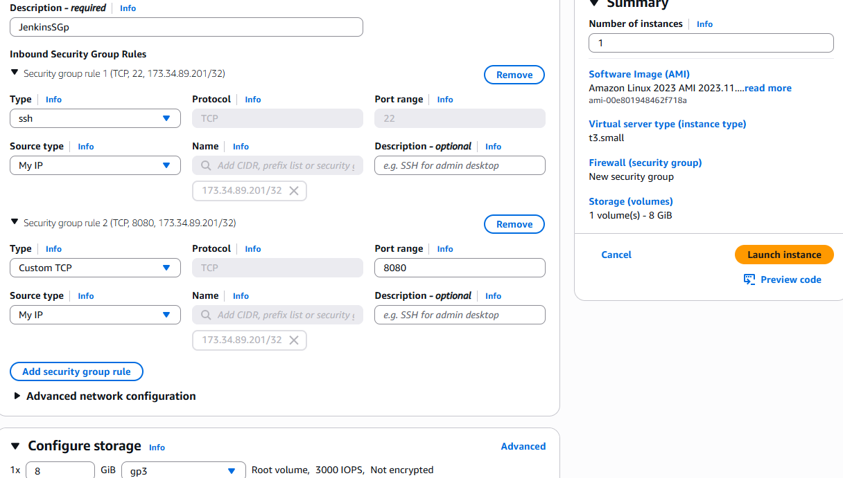
Step 2: Install Jenkins (The "Hard" Way)
- SSH into your instance (or use EC2 Instance Connect).
- Run these commands one by one (Explanation: We are adding the Jenkins repository and installing Java):
- sudo yum update -y
- sudo wget -O /etc/yum.repos.d/jenkins.repo https://pkg.jenkins.io/redhat-stable/jenkins.repo
- sudo rpm --import https://pkg.jenkins.io/redhat-stable/jenkins.io-2023.key
- sudo yum upgrade
- sudo dnf install java-17-amazon-corretto -y
- sudo yum install jenkins -y
- sudo systemctl enable jenkins
- sudo systemctl start Jenkins
error
- sudo systemctl status jenkins.service -l
- get the logs --------
- which java
- readlink -f /usr/bin/java - /usr/lib/jvm/java-17-amazon-corretto.x86_64/bin/java
- sudo systemctl edit Jenkins
- paste
  - [Service]
  - Environment="JAVA_HOME=/usr/lib/jvm/java-17-amazon-corretto.x86_64"
  - ExecStart=
  - ExecStart=/usr/bin/java -Djava.awt.headless=true -jar /usr/share/java/jenkins.war

- Run this to kill any half-started Jenkins processes:
- bash
- Collapse
- Copy
- sudo pkill -9 java

- Step 3: The "Simple" Start Method
- Instead of using the complex systemctl settings right now, let's use a more direct method that is easier to debug and lighter on the system.
- Check if Java is actually there:
- bash
- Collapse
- Copy
- java -version
- If it says "command not found," run: sudo dnf install java-17-amazon-corretto -y
- Download the Jenkins "WAR" file directly (The most reliable way):
- bash
- Collapse
- Copy
- sudo wget http://mirrors.jenkins.io/war-stable/latest/jenkins.war
- Run Jenkins with limited memory: This command tells Jenkins: "Only use 512MB of RAM so you don't crash my server."
- bash
- Collapse
- Copy
- java -Xmx512m -jar jenkins.war

MAKE 21 THE BOSS NOT 17 java version
Now get password: ed4d5c8ce8214f3d8939065c86205eef
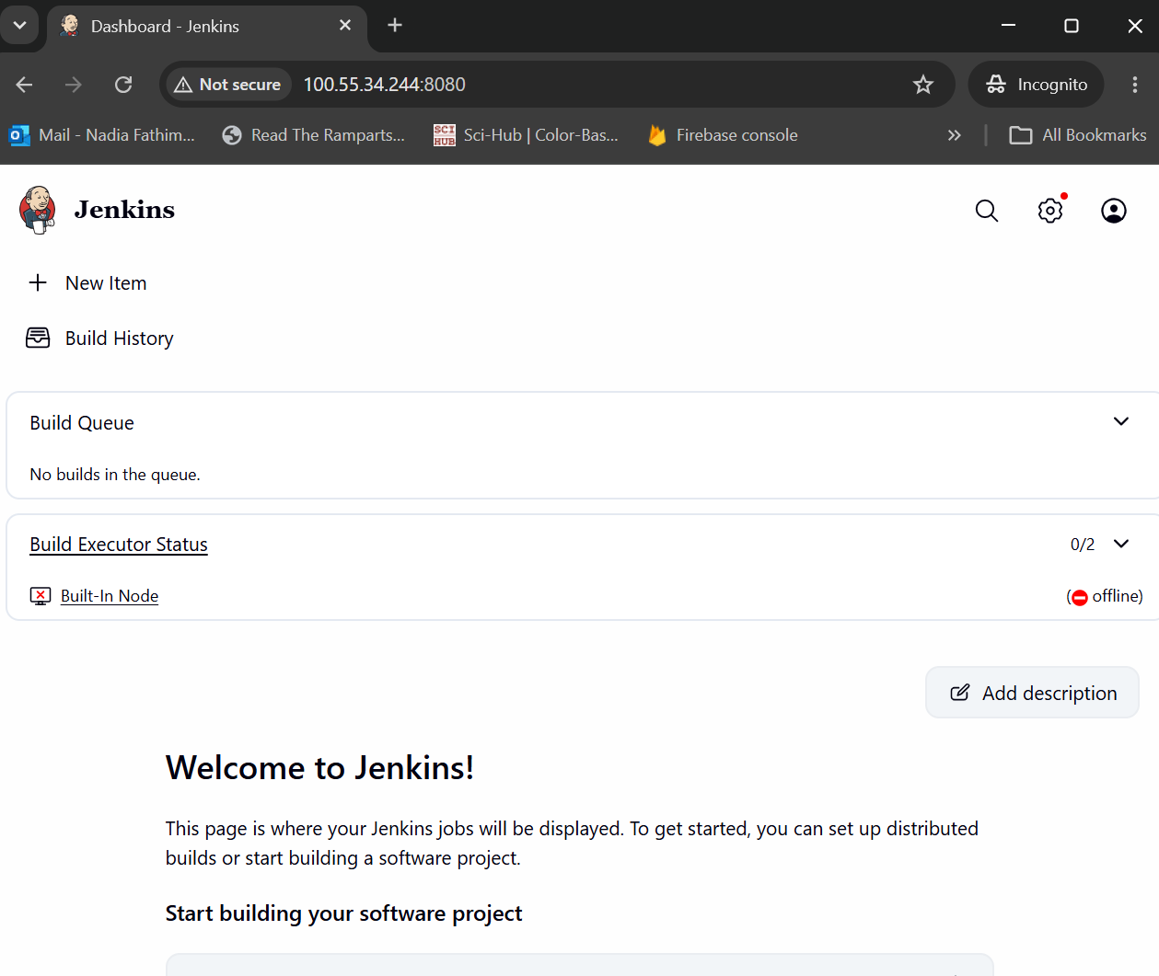
Step 1: Install Required Tools on the Jenkins EC2
Jenkins needs git and zip installed on its "home" server to work.
- Go back to your SSH terminal (where Jenkins is running).
- If Jenkins is running in the foreground, press Ctrl+C to stop it.
- Run this command to install the tools
sudo dnf install git zip -y
nohup java -jar jenkins.war &
Step 2: Install Plugins in the Jenkins UI
- In your browser, on the Jenkins home page, click Manage Jenkins (left sidebar).
- Click Plugins.
- Click Available plugins on the left.
- Search for and check the boxes for:
  - Pipeline: AWS Steps (Allows Jenkins to talk to AWS).
  - GitHub Integration (Allows Jenkins to talk to GitHub).
- Click Install and wait for them to finish (you might need to check "Restart Jenkins" when done).
Step 3: Create your First Pipeline
- Go back to the Dashboard.
- Click New Item.
- Enter an item name: Project5-3Tier-Pipeline.
- Select Pipeline and click OK.
- Scroll down to the Pipeline section.
- In the Definition dropdown, make sure Pipeline script is selected.
- Paste this script into the box (Replace the GitHub URL with yours):

